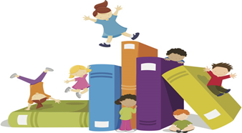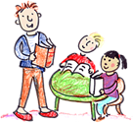

1000 Books Before Kindergarten

Name:__________________________________________________________________________